|  |
| --- |
| UAS Software Development Project 1 |
| City Card System “CCS” |
| Software Design Document |

|  |
| --- |
| Group 7 members:  Karim Abdelrahman (t9abka00)  Alexander Veliev (t9veal00)  Abdeljalil Misbah (t9miab00)  Jami Hannus (t9haja00)  Date : 16.03.2020 -XX.04.2020 |

# Introduction

Backend system for card like the Oulu city's Waltti RFID card. But we mainly forget card and concentrate on the back end. Will have database what connects the Id on the card to the credits deposited on the service and privileges the card has been given. One part of the idea is that it could be modular. So, we make the core of the program and its easy add more data or services to the id.

The base of the planning will start from the MVC model.

The user is split in 3 tiers

* Guest. User who does not have and Id yet.
* Id what is automatically created for user card is received. So, one can have Id with registration.
* Registered user. Id + account that the user registered.

Included in document you can find our database model, some ideas about the interface and lastly in last part about the project work.

# User Interface

Very basic. Header, Main and a Footer. Some buttons. The retro feeling.

Function over form.

Will have at least the following pages Some could be combined or split up

1. Main page - Sign in or guest Maybe could log in with the id only. So, guest could look at the site and the services without the Id. If you know the ID, you can recharge it. Like I can charge my grandmother card. But if one creates and account, they will get more options. Like save payment info. More complete auto fill. Subscription options, and many more services.
2. User profile page. Mainly used for user that have account bound to ID. But you could show something with the Id what the user has allowed to be shown.
3. Credits. See amount of credits on the card for gym or maybe bus ticket
4. Subscriptions. Like you have a monthly bus card.
5. Payment page. We don’t simulate the payment system. Only want to know what you want to use and if you want to save the used system for later use too. Like pick from credit card, bank transaction or PayPal. Could add many systems. The main points would be to maybe save the used payment system on some table.
6. Info page. What is this card. What is the system. How to use it. It could have contact information.
7. Optional – Admin page. If we have time, we could add a support page for the support personal. It could see the info and help if there are any problems.

# Database

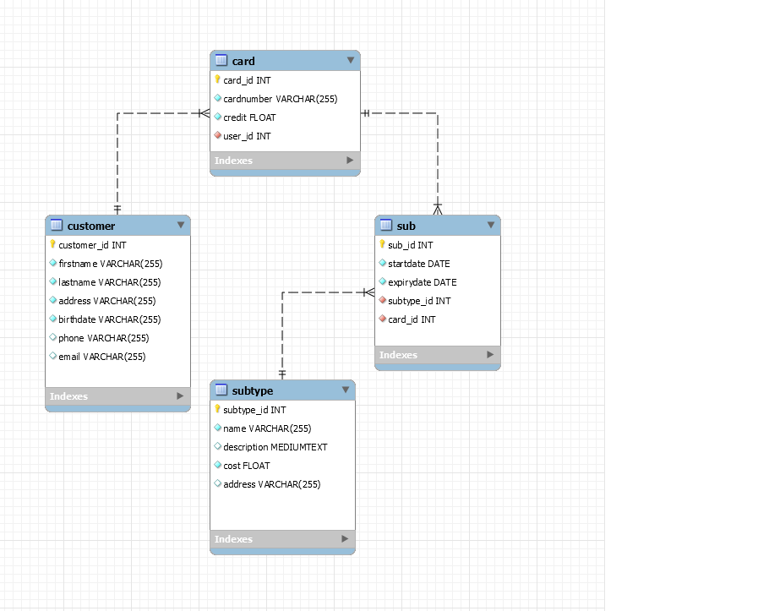

The plan is to have 4 tables. Customer table has the info of the costumer. Card will be main table. It will save the credit what can be used to buy services too. Or use the card as value card. Sub table will have the privileges/products what the costumer has bought to the card. It also can be used to create subscription history of the user. Then lastly the subtype table will have the important data of the subscription type. Is it a bus monthly ticket or a gym yearly membership?

Maybe need one for the payment system too? Will depend how we will simulate it.

# Development plans

## What programming languages / tools you are going to use?

PHP, Html, CSS and JavaScript.

We use the CodeIgniter framework

We use GitHub repository to track work. It is used it so team member needs to check ones work before it can be merged into the main branch.

## How you are going to divide the work, i.e., who is going to do what?

Everyone will do something. Some people will do more some less.

At this point we have 4 tables in database so everyone will get 1 to manage.

The pages will be done split way too. But main point would be that everyone will do everything or at least understands the code of other parts of the code.

16.3.2020 was the first meeting on Microsoft teams. VoIP call